**Experiment Number – 08**

**Aim:** Write C++ program using Simple Parameterized Constructor for Find Prime Number.

**Objective:** To check whether a number is prime or not with help of parameterized constructor.

**Flowchart:**

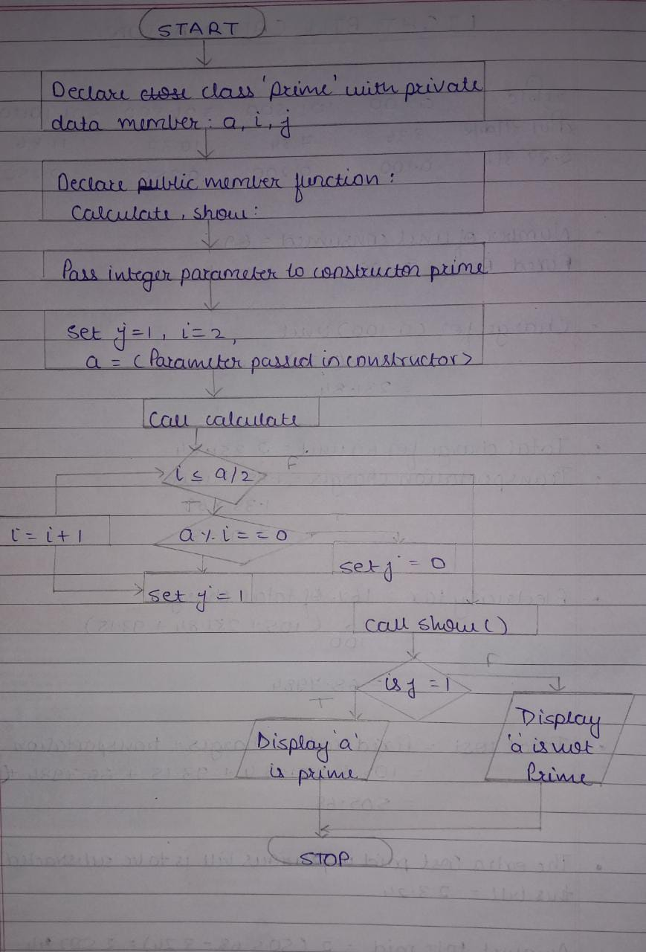

**Algorithm:**

1. Start.

2. Declare the class ‘Prime’ with integer data members ‘a’, ‘i’, ‘j’ under private access specifier

3. Declare Member functions: ‘calculate’, ‘show’ under public access specifier.

4. Consider Constructor ‘Prime’ with an integer parameter.

5. Within the constructor, Set j = 1, i = 2, a = <parameter passed to constructor>

6. Call the function calculate() and perform the following steps.

* Start a For loop with i = 2 to a/2
* Check if a % i = = 0 then set k=0 and break.
* Else set k value as 1.
* Increment the value i as 1.

7. Call the function show() and perform the following steps.

* Check whether the k value is 1 or 0.
* If 1 then display the value is a prime number.
* Else display the value is not prime.

8. Stop.

**Program:**

**# include<iostream>**

**using namespace std;**

**class prime**

**{**

**int a, j, i;**

**public:**

**prime(int x)**

**{**

**a=x;**

**j=1;**

**}**

**int calculate()**

**{**

**for (i=2; i <= a/2; i++)**

**{**

**if(a % i == 0)**

**{**

**j=0;**

**break;**

**}**

**else{**

**j=1;**

**}**

**}**

**return j;**

**}**

**void show()**

**{**

**if(j == 1)**

**{**

**cout<<a<<" is a prime"<<endl;**

**}**

**else**

**{**

**cout<<a<<" is not a prime"<<endl;**

**}**

**}**

**};**

**int main()**

**{**

**int a;**

**cout<<"enter number:"<<endl;**

**cin>>a;**

**prime p1(a);**

**p1.calculate();**

**p1.show();**

**return 0;**

**}**

**Output:**

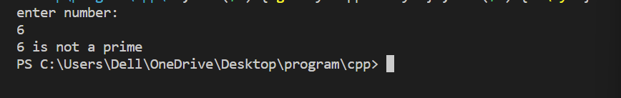

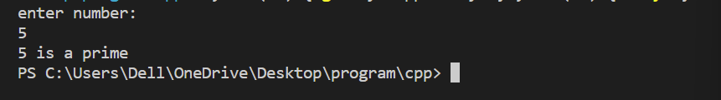

**Conclusion:**

With the help of parameterized constructor, user input values can be passed to objects of class and this property enables us to check if a number is Prime number or not.

**Submitted By:**

Name: Siddhesh Dilip Khairnar

Roll Number: 1421

PRN Number: 22110398

Division: N

Batch: N1